Girls Build – LA Promise Fund
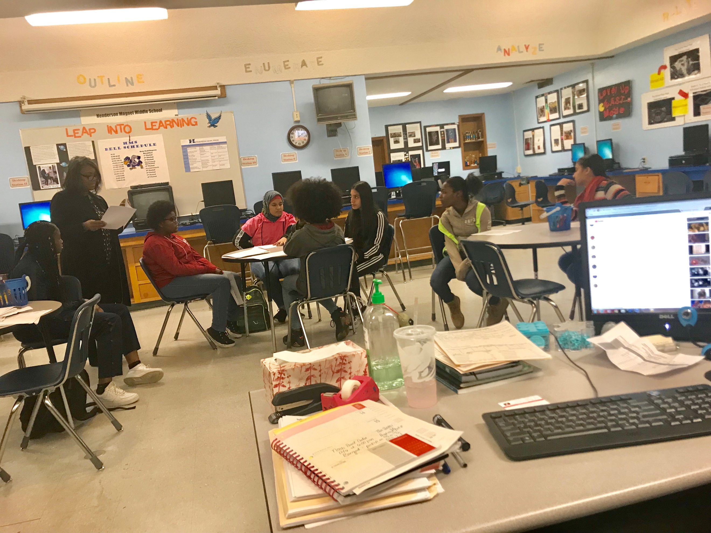

http://www.lapromisefund.org/girls-build

This is a program where High School and Middle School teams apply to join Girls Build. Girls Build ask young women to identify an issue they face in their lives and through the program, produce a solution to effect positive change in their communities. LA Promise Funds selects 50 teams to compete in the Girls Build Challenge.

